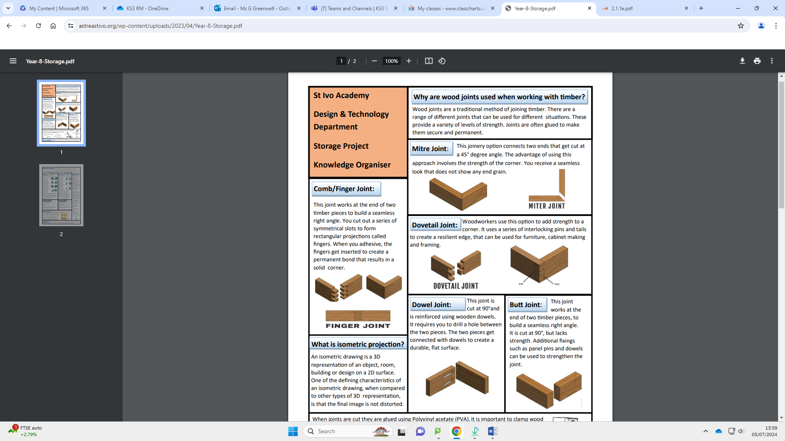

**Key Words:**

* DESIGN BRIEF that outlines the

product to be designed.

* RESEARCH – is the investigation into materials to be used, manufacturing methods, look at other existing and iconic products. This process will help you design a better suited product.
* SPECIFICATION – is a set of criteria that a design must meet in the design and manufacture stages. The specification points are set from a design brief.
* MANUFACTURING PLANS – plans are made as to the stages of production. Tools and equipment, time, health and safety and quality assurance will all be included in a detailed plan.

**Designing and the Environment**

**Reduce**: Cutting down on packaging is a great way of reducing unnecessary waste that is not really an essential part of the product we purchase.

**Reduce**: Reducing plastics where possible will be a massive gain. Plastics can be difficult to recycle and biodegrade, so finding an alternative would be very helpful.

**Recycle**: Recycling waste correctly is another area for improvement.

**Repair**: Repairing products or choosing not to upgrade when a newer version becomes available can be beneficial.

**Materials:**

**MDF** is made from small fibres which are mixed with a wax and resin, then heated and compressed into the desired thickness. MDF has no grain, and is easy to work. It is popular for interior DIY furniture.

**Plywood** is made from layers of wood, bonded together at an angle of 90 degrees to increase strength and rigidity. Sometimes, the facing layers can be high quality, e.g. birch, to provide a better aesthetic finish

**Pine** is a pale-yellow coloured wood with darker brown grain. It is lightweight, easy to work, used for construction and furniture products.

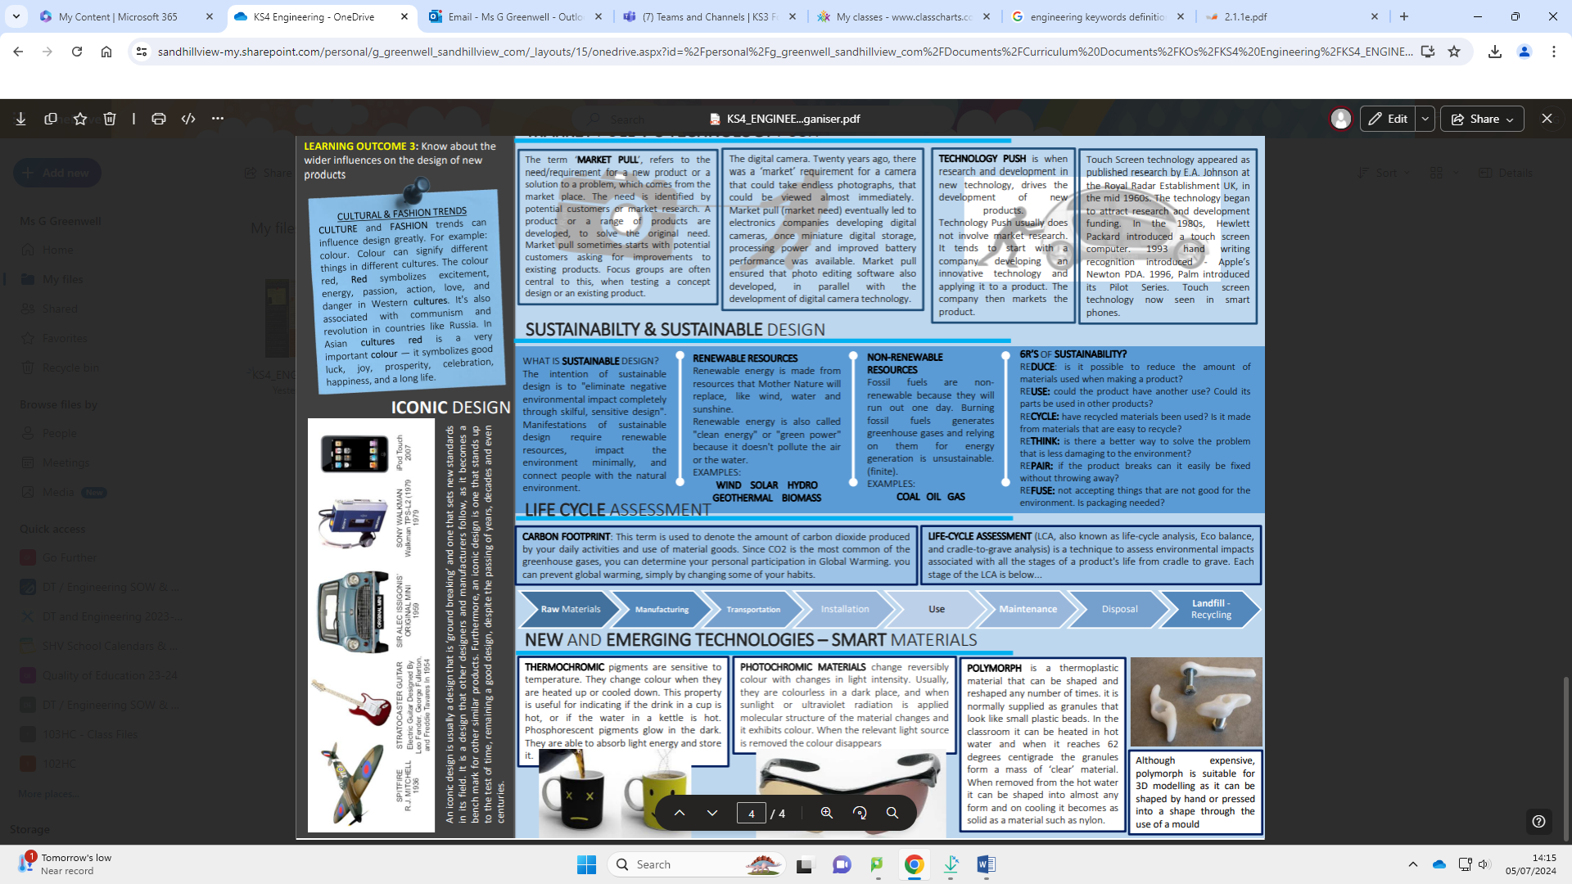

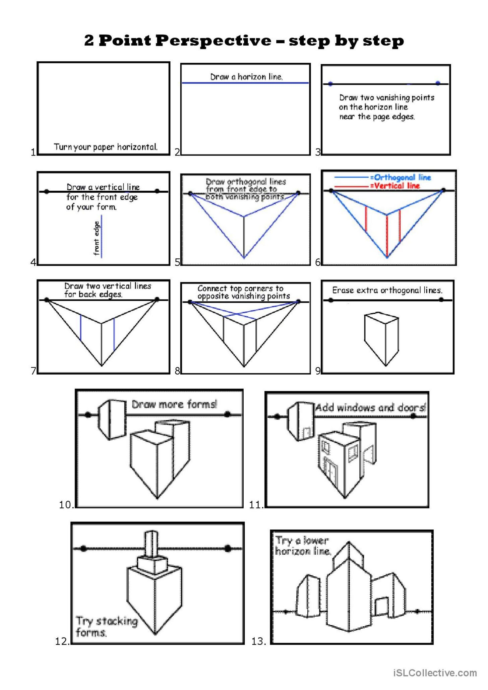



Y9 Resistant Materials

**Year 9 Technology**