**PPE** stands for Personal Protective Equipment, which includes items like goggles, gloves, and masks that you wear to keep your‐ self safe from things that might hurt you while you're in the workshop.

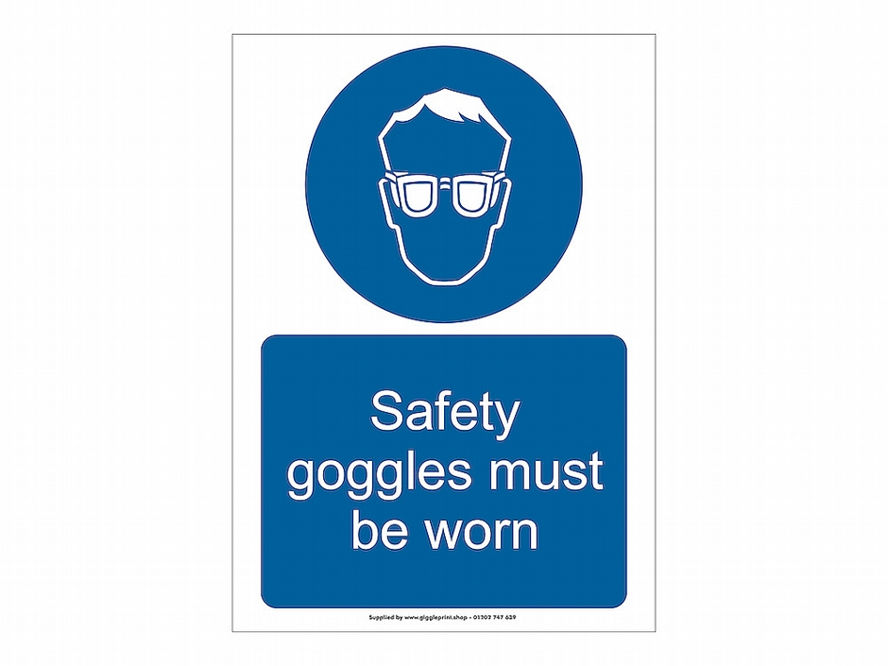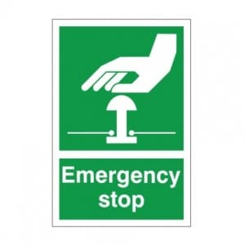



**Materials:**

**Hardwood:**

Hardwoods come from deciduous trees, which have large flat leaves that fall in the autumn. Hardwoods take longer to grow, are not easily sourced and are expensive to buy.

**Softwood:**

Softwoods come from coniferous trees. These often have pines or needles, and they stay evergreen all year round - they do not lose leaves in the autumn. They are faster growing than hardwoods, making them cheaper to buy, and are considered a sustainable material.

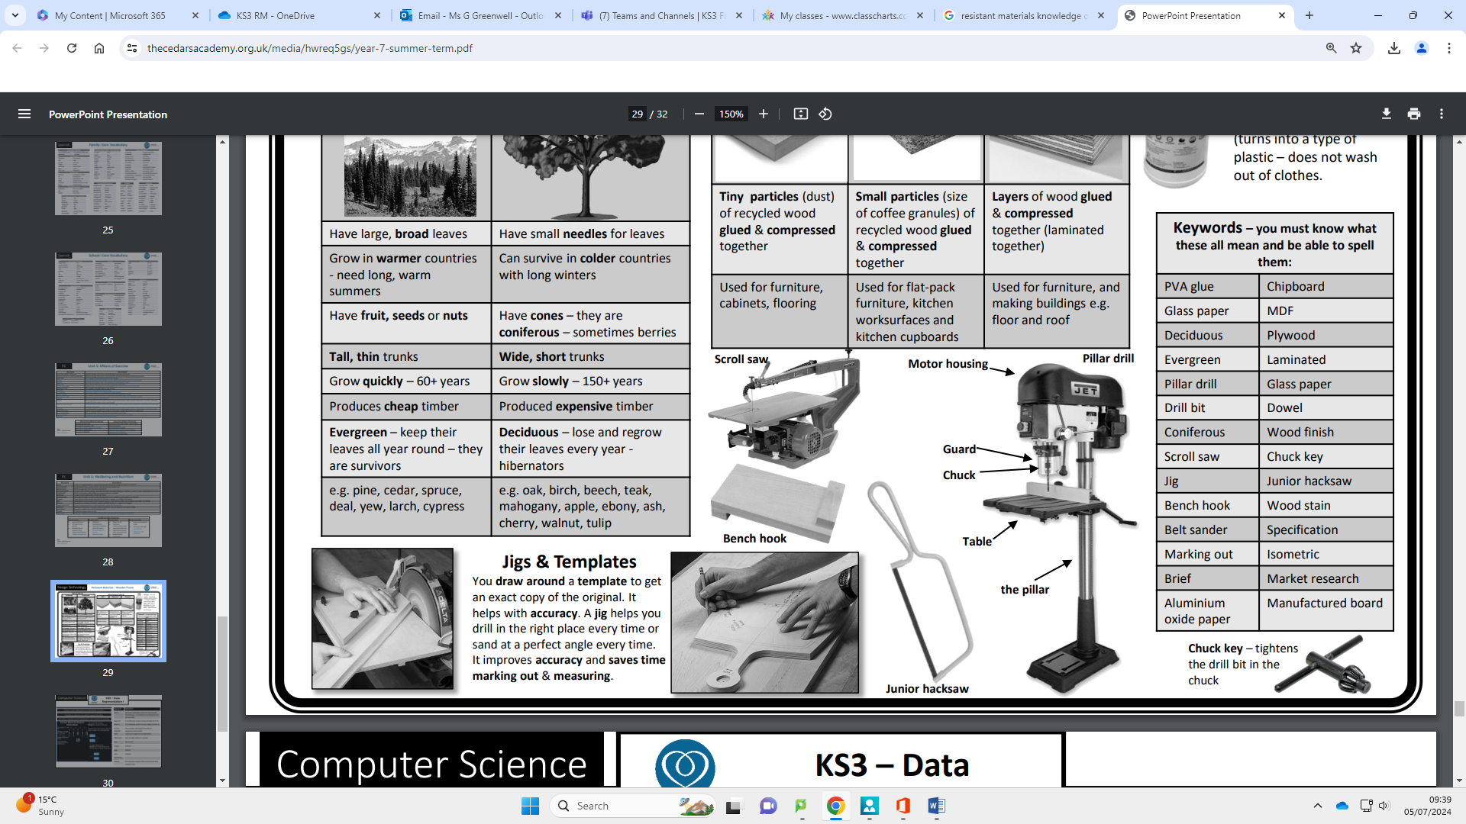

**Selecting Materials:**

Once a design engineer has taken into account all of the physical and working properties of the material, they should address these areas:

•Functionality - Does the material perform in the way that is required?

•Aesthetics- What does it look and feel like?

•Environmental considerations- What impact does it have on the environment during extraction and processing? Does it require chemical treatment and can it be recycled?

•Availability – What stock forms does it come in and are they fit for purpose?

•Social, cultural and ethical considerations - Does the material have any a special cultural value or come from an endangered or unethical source? What were the working conditions for those extracting the material?

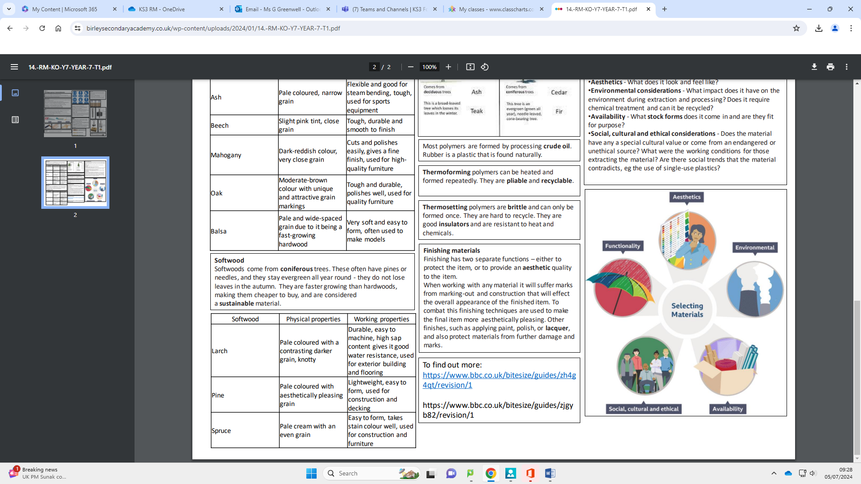

**Finishing materials**

Finishing has two separate functions – either to protect the item, or to provide an aesthetic quality to the item. When working with any material it will suffer marks from marking-out and construction that will effect the overall appearance of the finished item.

To combat this finishing techniques are used to make the final item more aesthetically pleasing. Other finishes, such as applying paint, polish, or lacquer, and also protect materials from further damage and marks.

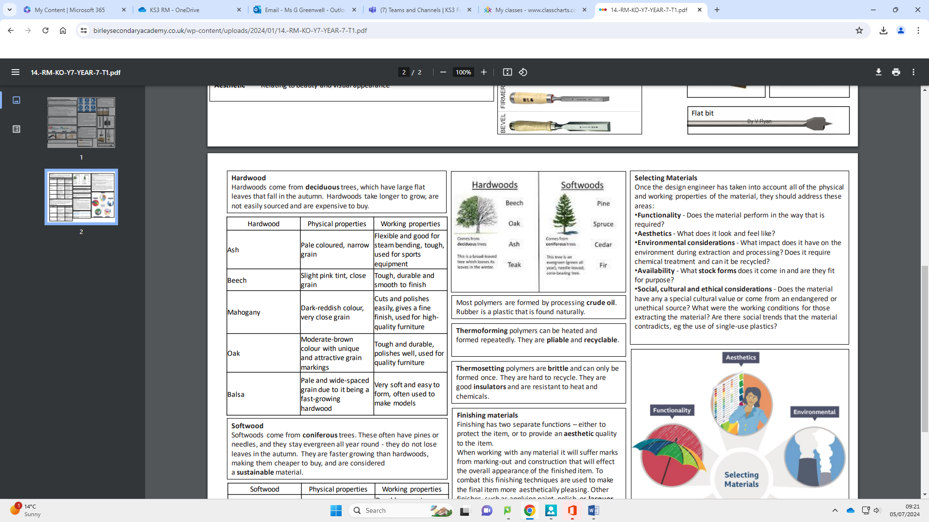

Y8 Resistant Materials

**Year 8 Technology**